Developing Technologically Enhanced Learning Spaces for New Millennia Academic Libraries

Raymond Uzwyshyn
Division of Research Collections and Management Strategy, Mississippi State University Libraries, Starkville, Mississippi.
ruzwyshyn@gmail.com

Copyright © 2023 by Raymond Uzwyshyn. This work is made available under the terms of the Creative Commons Attribution 4.0 International License: http://creativecommons.org/licenses/by/4.0

Abstract:

As a third place of community and learning, university academic libraries are shifting from quiet study spaces for reflection and inspiration to spaces of creation, technology and interdisciplinarity. Information technologies, media technologies and learning technologies are rapidly expanding in academic libraries. Spaces such as digital media centers, digitization and 3D printing labs, and technology-centric digital literacy classrooms are now regular features in university libraries. Makerspaces and research data visualization walls have also become more common. These new types of integrated social and technology enhanced spaces enable new forms of literacy (digital, algorithmic, information-based) and learning for wider communities. This research overviews considerations and conceptual ideas towards envisioning and creating these types of spaces in our new millennia. It utilizes material from early-stage and completed projects to discuss conceptual synthetic ideas for development. Challenges of possibilities for integrating existing traditional library spaces in an existing structure with new spaces of technology will be discussed. Innovative antecedent and recent models of current technology enhanced learning commons including Texas State University Libraries (2014-2020), the University of West Florida (2011, Skylab), University of Miami Information Commons (2006) and early-stage projects (Mississippi State University, 2023) are referenced to reflect on new technology/architectural possibilities. Challenges towards reconfiguring the 20th century classroom towards 21st century learning technology possibilities are reflected upon. Pragmatic realities and visionary necessities of creative re-envisioning spaces will be emphasized to better create technologically enhanced libraries suitable for the 21st century.

Keywords: academic libraries, architectural spaces, information technology, digital literacy, innovation

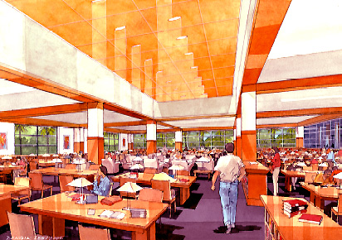  University of Miami Library Information Commons (2003),  Architectural Rendering | 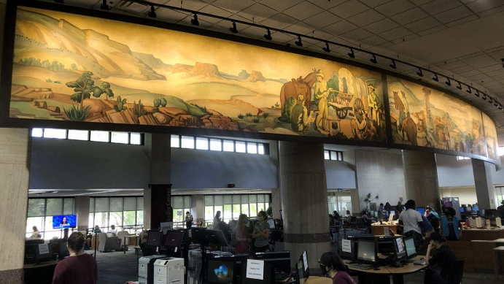  Texas State University Learning Commons (2023), Photograph

Introduction

The need for enhanced information technology spaces and library architectural redesigns present new opportunities for academic libraries in the new millennia. Through technological reimagining of library spaces, new digital and algorithmic literacy infrastructures for the 21st century are enabled. This ranges from possibilities with AI, data and immersive technologies to new algorithmic and digital literacy labs requiring better learning enabled architectures.

This research pragmatically focuses on four US academic research and teaching university libraries which highlight possibilities for building these new types of spaces: University of West Florida, John C Pace Library, Texas State University, Albert Alkek Library, University of Miami, Otto Richter Library and Mississippi State University Margaret Mitchell Memorial Library. This article highlights best practices and lessons learned from work and reflections over a twenty year period on small, medium, large and x-large, leading-edge, technologically enhanced library architectural projects (See Uzwyshyn, References 2003-2023). This ranges from very large multi-year projects (Texas State Learning Commons, 2014-2021) to medium size technology enhanced floor redesigns (University of West Florida Skylab, 2006-2010) to new larger projects currently in early developmental phases (Mississippi State Library Transformation, 2023). The work here also glances at early information commons (University of Miami Information Commons, 2003) and consistent threads to help future brainstorming and digital literacy. It emphasizes the need for imagination and imagineering technologically enhanced projects and spaces. This work in this way reflects on technology’s path forward through a look back and forward view to the future of academic libraries to suggest pragmatic paths and visionary possibilities in creating new architectural spaces with new technologies for libraries.

In Media Res: The University of West Florida Skylab (2006-2010)
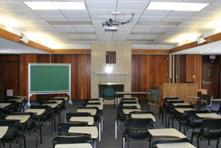  University of West Florida 20th Century Library Classroom | 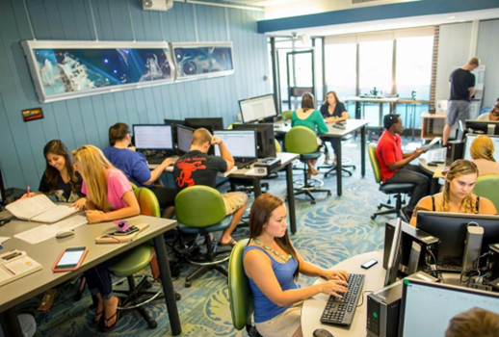  University of West Florida 21st Century Skylab  Information Literacy Lab/Classroom
Perhaps it is best to introduce the topic of ‘technology-enhanced spaces in libraries’ as ‘In Media Res’ or the historical middle of a narrative through the unifying theme of libraries and literacy. What does it mean for a person to be literate in the 21st century? Simply put, it means an educated literate person in our new millennia must be digitally literate. They must be able to use the necessary tools to write, read and communicate globally on the web through a variety of media formats and tools. The University of West Florida Skylab (envisioned in 2006, completed 2010) conceptualizes this project. Skylab was an approximately 1M dollar USD project to take back the John C. Pace’s library’s fifth floor from university administration. The space rearticulates an outdated 20th century classroom and library structure to reclaim a new digital literacy definition as a technology enhanced library learning center and information literacy lab. Here, the Skylab envisioned a tripartite technologically enhanced redesign of the library fifth floor (Uzwyshyn, Envisioning, 2010). This consisted of an information literacy classroom lab, multimedia digital literacy studio and digital literacy and media conversion center for students and faculty. While the old classroom consisted of a Cartesian grid-like structure, more suitable to the industrial revolution of the 19th and early 20th centuries, the new space focused on commingling group study, technology rich areas and a rearticulation of the classroom through technological possibility. Key differences in this type of space sought to spatially rearticulate new areas and thought regarding learning and literacy needs. This included new teaching methodologies, classroom settings, teaching roles, resources, and technology possibilities. It also included new special ideas regarding collaboration, engagement, technological skills, and new learning space requirements. These new spaces sought to efface 19th century industrial revolution parallels. This included a larger paradigm shift, from rote learning and a lectern at the front, to active learning. Spatially, there was a replacement of the previous uniform grid like Cartesian rows of desk classroom to more flexible and varied layouts to promote collaboration and adaptability and integration of an abundance of advanced technologies. This shift also involved new conceptual ideas of student engagement. Student roles had changed from passive receptacles of information to active student engagement via participatory learning technologies. The teacher no longer stood at the front as a primary source of authority but was now a more decentered but important assistive guide and facilitator. Necessary skill levels also shifted and increased from basic reading, writing and research to digital, algorithmic and database search literacy and suitable associated modalities. (See Table One below for further detailed comparison).
Characteristics of  Learning Spaces | 19th Century Classroom  (1st Industrial Revolution) | 21st Century Classroom  (4th Industrial Revolution)
Learning Methodology | Rote learning, focused on memorization and repetition. | Active learning, emphasizing creativity, critical thinking skills.
Classroom Setting | Uniform grid-like Cartesian rows of desks, with teacher at the front; "one-size-fits-all" approach. | Flexible and varied layouts that promote collaboration, adaptability and personalized learning environments.
Teaching Role | Teacher-centered instruction, with teachers as the primary information source. | Student-centered instruction, with teachers as assistive guides and facilitators.
Resource Availability | Limited resources - primarily textbooks and physical materials. | Abundance of resources - digital e-textbooks, online materials, multimedia, OER and Open Access resources.
Technology Usage | Little to no technology in classrooms. | Integration of advanced technologies (laptops/tablets, phones, learning management systems, online libraries, digital whiteboards, multimedia, interactive technologies
Collaboration | Individual-focused tasks and desks, limited group work. | Emphasis on teamwork, collaborative projects, online global classroom collaborations.
Student Engagement | Passive receipt of information, limited student engagement. | Active student engagement via interactive, participatory and personalized learning technologies.
Access to Information | Limited access to information, confined to school hours and physical materials. | Anytime, anywhere access to information large bandwidth digital connectivity.
Skills Emphasis | Focus on basic literacy and numerical skills. | Emphasis on 21st century digital and algorithmic literacy, creativity, critical thinking, problem-solving, communication, collaboration.
Learning Pace | Uniform pace of instruction for all students. | Personalized learning pace, enabled by adaptive learning technologies.
Table 1: Factor and Characteristics Comparison and Contrast of 19th and 21st Century Classroom and Academic Library Learning Spaces

Intersectional Spaces, Innovative Technology, Interdisciplinary Learning & Research

Rearticulating the 20th Century Cartesian Library Classroom Grid
with Faculty and Student Interdisciplinarity and Enhanced Technological Intersections
The University of West Florida Skylab reimagined the 19th century space of learning in terms of enhanced technology possibilities for the classroom. It also rearticulated the libraries third social space in terms of digital literacy. This reclaims a Gutenberg type role for the library and renaissance set of possibilities for digital literacy as the intersections of a broad cross fertilization of projects, people, tools and skillsets. This was also a first move towards 4th industrial revolution ideas. It reflected our new millennia era’s rapid technology changes in societal patterns, social processes, and new possibilities for areas, ranging from interconnectivity, learning to technology, and putting forward the academic library in its best light. The Skylab included a multimedia studio, digital literacy classroom and media conversion center and associated services.
Information
Digital Literacy Lab
Media
Conversion Center
Multimedia Studio
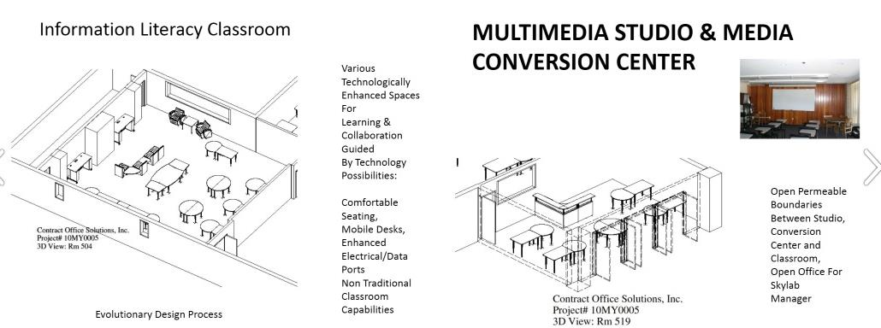
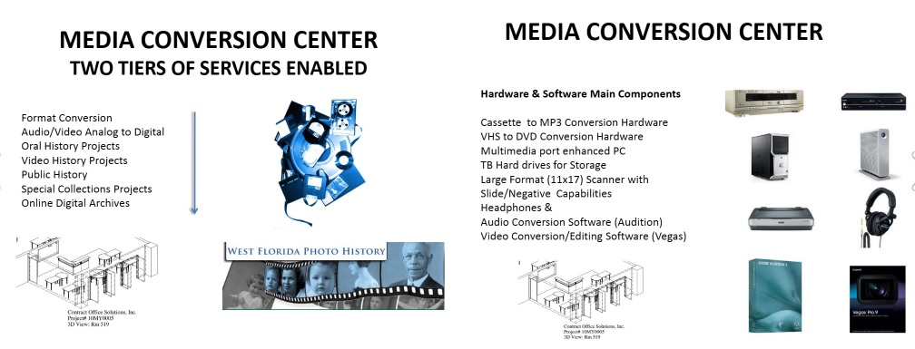
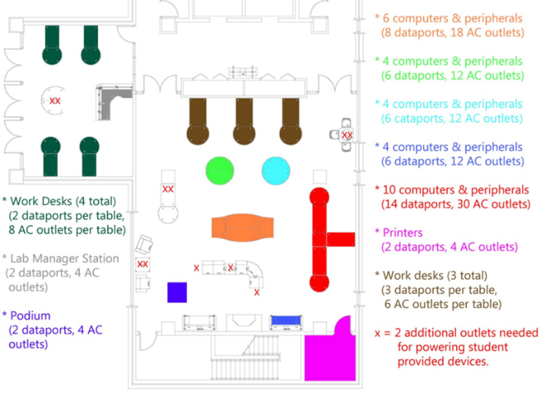
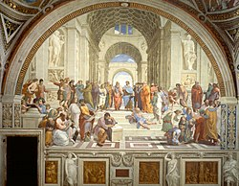
University of West Florida Skylab, Technology, New Services and Space
School of Athens, Raphael, Skylab, Enhanced Classroom Data and Electrical Needs
Renaissance Models of Interdisciplinary Learning

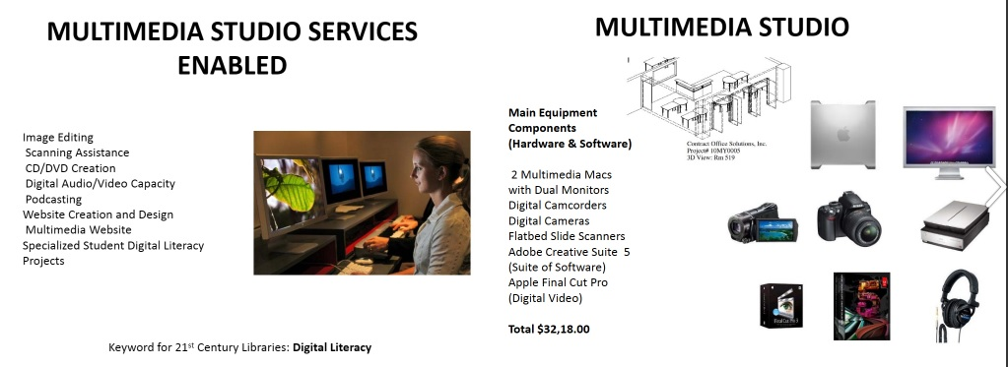
Texas State University Learning Commons and Alkek One (2014-2021)
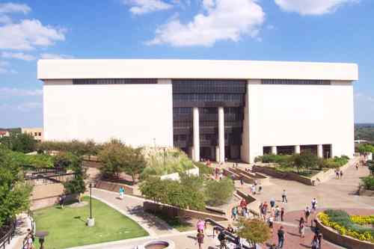
Albert Alkek Library, Texas State University
The Texas State University Learning Commons and Enhanced Technology Transformation expanded and continued these ideas. This very large project occurred over a seven year period (2014-2021) transforming TXU’s Alkek Library from a 20th century hieroglyph (a vast book warehouse academic library model) to a 21st century multi-tiered Learning Commons refocused on new millennia student success and new faculty research and teaching possibilities. Texas State University was a Carnegie Class R2 Doctoral University of approximately 40,000 students and faculty and focused on higher research activity. This multi-year and multi-stakeholder project involved building on previous University of West Florida ideas. A full decade later, with more mature technologies, there was wider acceptance of a broad spectrum of enhanced multimodal technologies with more possibilities for interdisciplinarity (Video Tour, 2020). The eventual 40M USD project consisted of 3-5 multi-year planning and build phases. These involved architectural programming, design, technological implementation, and many voices. For brevity’s sake, this XL large 40 M USD project may be divided into three larger phases.
- Phase I: Infrastructure Upgrade: Electrical/Data, 2014-2017. 5M
- Phase II: Mid-Term Learning Commons/Library Transformation of Spaces/Floors: Furniture/Special Collections, Offsite-Repository (ARC)/1M Books Moved, 2016-2019. 10M
- Phase III: Alkek I, Future Learning Spaces/Themed Centers, 1st Floor Technology, Immersion Studio (VR), GIS Lab, Makerspace, Smart Classrooms/Digital Media Labs/Studios (2018-2020). 25M

Before going into any larger project like this, a few caveats and generalizations are in order. These involve design parameters/constraints for this type of larger space-enhanced technology project. Before going into any project of this size, larger facets, regarding project management, should be closely examined. Major considerations include: budgetary allowances, university administrative directions, donor possibilities and human resource requirements. Staff, stakeholder/university interests, library and university work culture, social factors and current and future library needs should all be reflected on carefully. Planning principles regarding technology enhanced learning spaces should be adhered to in larger aspects. The most important of these, in the author’s 20-year experience, is that ‘technologies deployed in academic libraries in the 21st century will change over time. Planning should reflect this by allocating appropriate space without necessarily establishing a specific technology for each space’. In this regard, it’s wise to glance back retrospectively at conceptual changes for library learning spaces and technology in the past twenty-five years and new millennia, roughly 2000-2024 moving forward.
Library Commons General  Developmental Periods | Historical Space/Technology Conceptual Changes  in 21st Century Library Learning Commons
2000-2000, Early PC Phase  Information Commons  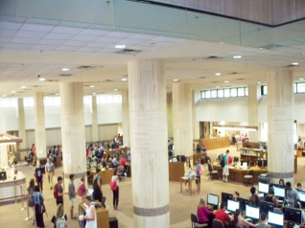 | Initial Information Commons Adoption Phase
 | - Libraries are still primarily viewed as physical repositories of books and materials (Book Warehouse Phase).
 | - Initial integration of technology: PC’s and online databases begin to complement and displace traditional print resources.
 | - Onset of information commons, higher speed network throughput, connectivity, Wi-Fi enabled spaces allow users to use their own devices.
 | - Early adoption of online e-books and digital media database content occurs.
 | - Innovative libraries start experimenting with makerspaces.
2010-2020, Digital and Cloud Integration Phase 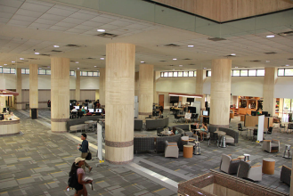 | Transition to Learning Commons, Digital Integration Phase, Ver 1.0
 | - Rapid proliferation of mobile technologies, increased demand for digital content,Wi-Fi bandwidth continues to increase.
 | - Libraries adopt more technology, self-service kiosks, digital repositories, 3D printing lab. The library becomes the university’s largest computing lab.
 | - E-books, online journals, and digital databases become dominant. Books and bound journals begin to be moved out.
 | - Libraries transform into collaborative student/faculty digitally enabled learning spaces. Areas for group study, digital collaboration, research and learning.
 | - Introduction of widespread digital and data literacy programs, data research repositories, technology training workshops, micro-credentialling.
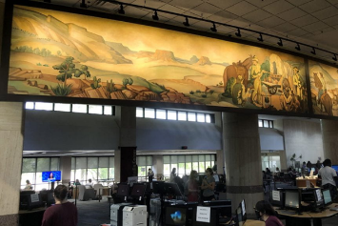  2019-2023+ | Digital Transformation Expansion Phase – Learning Spaces
 | -Mobile, digital, media and communications technologies become ubiquitous, reshaping libraries into multidimensional learning commons.
 | - Complete acceptance of BYOD (Bring Your Own Device) culture. Libraries provide charging stations, digital resources, and robust Wi-Fi.
 | - Almost complete shift towards cloud-based resources and media for storage and access to cloud-based digital materials is seen.
 | -New integration with emerging technology: AI, AR/VR/XR labs, IoT, data research repositories and associated library ‘help’ services begin.
 | - Libraries increasingly integrate makerspaces, digital media labs, data, digital and algorithmic literacy learning and innovation centers for faculty and students.

From Book Warehouse to Learning Commons

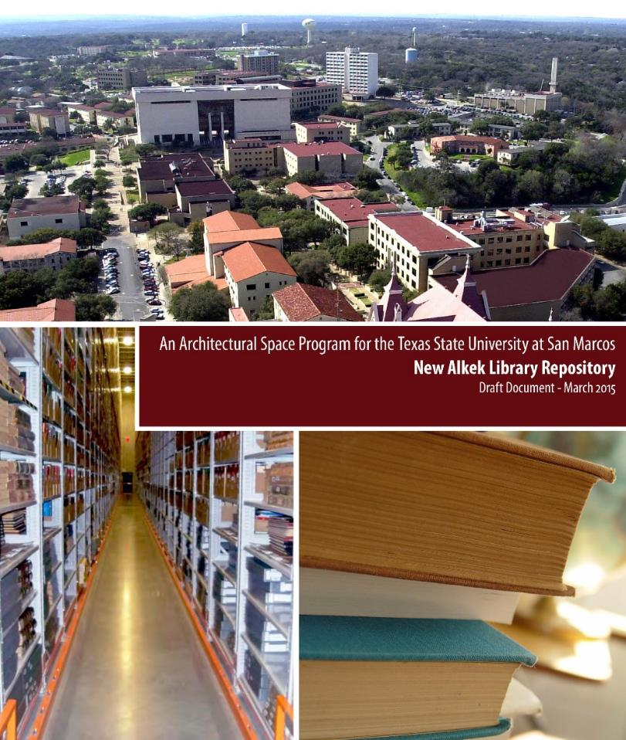 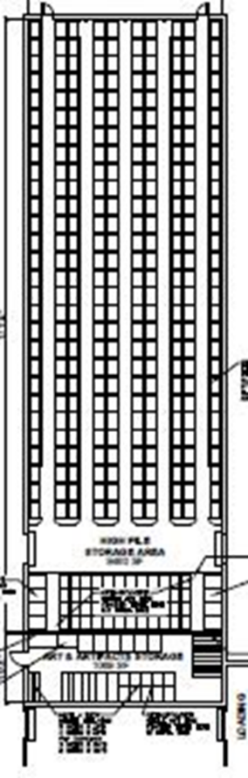
Texas State Offsite Repository Preliminary Planning Documents, 2015

In transforming any academic library book warehouse to a technologically enabled 21st century learning commons, large questions arise. First among them is what is to be done with the books and material holdings (i.e., bound journals, media, special collections archives)? How do we also best make room for new spaces needed for a technology and patron-centered learning commons? These larger challenges may be handled in many innovative ways. For Texas State University, in 2015, the solution was to build an offsite repository (10M USD) or, as it was later named, the ARC (Archival Research Center). This involved moving approximately one million of the four million monograph and the bound journal collections. Space will be needed for the makerspaces, digital studios, technology enabled study spaces and digital literacy labs. This will also require moving previously filled library stacks and, simultaneously, installing efficient information control structures regarding offsite inventory for these pathways and patrons who need these materials.

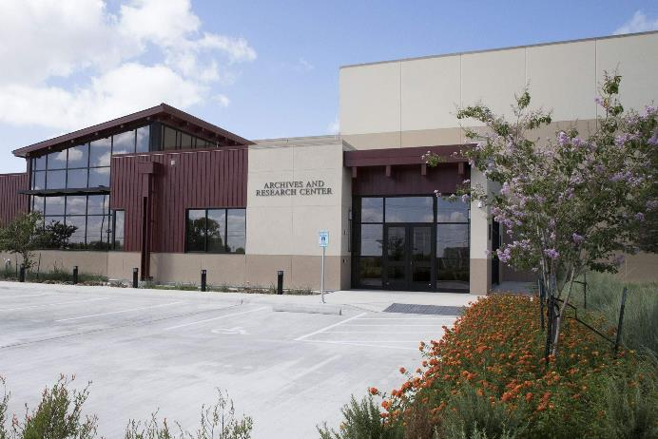
Texas State Offsite Archival Research Center, 2017
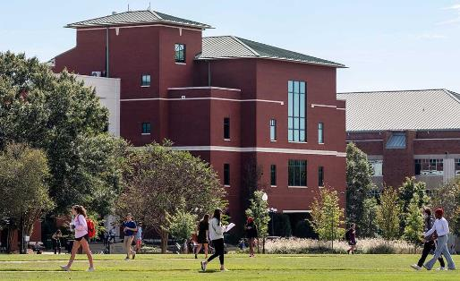
Other Space Enabling Possibilities – Digital Resources and Backfiles
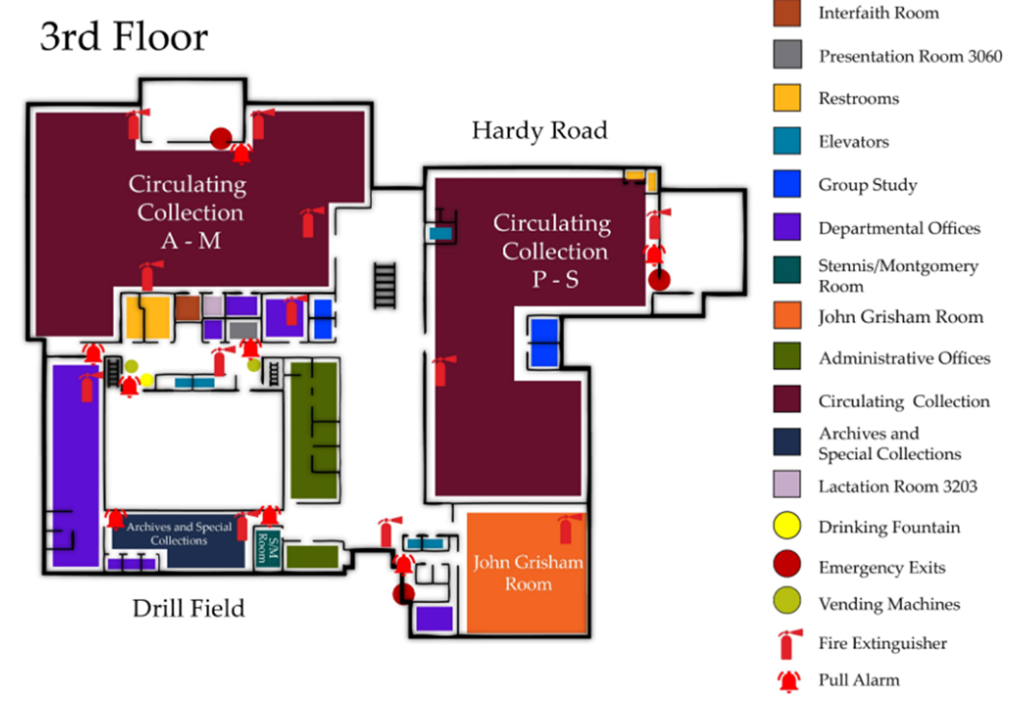
Third Floor, Mississippi State University Library, Circulating Collections,A-S
If building an offsite repository is not currently feasible in making room for new technologically enhanced spaces, there are also other possibilities. Monographic collections may be moved to other areas of the library while simultaneously converting unused larger bound journal collections to digital media to reside in the cloud. In early learning commons planning at Margaret Mitchell Library Mississippi State (2023), digital backfiles were purchased from the large historical research backfiles possibilities ranging from the Institute of Electrical and Electronics Engineering (IEEE) to JSTOR. Other very large historical journal storage digital archives covering large swathes of leading academic journals from STEM disciplines to the social sciences and humanities are increasingly available. Hathi Trust memberships may also be obtained for electronic borrowing as largely unused bound journal stacks are repurposed. Search preference modalities for academics working in the 21st century on article-based research weigh towards the database and instant search rather than muddling through stacks. These subscription, cloud-based possibilities may also be combined with space planning to affect larger innovative possibility.
Mitchell Memorial Library, Five Floors, 70,000 sq. ft.

Final Notes: Funding, Donors, New Models and Vision
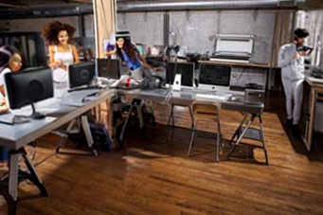
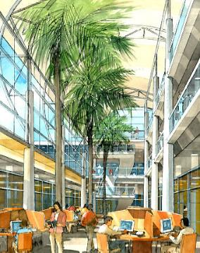
U Miami Commons 2003 Donor Mississippi State University Donor Adobe Firefly 2023
Architectural Renderings Generative AI Photographic Digitization Lab Visualizations

Funding and donors will be needed in building any new technologically enhanced library space. Whether this comes from university, state, national appropriations, or an interested donor or set of donors, a vision of the future and possibilities should be set. As much as possible, spaces should be more precisely described to gain funding. This new space planning begins with the ability to imagine, reimagine, and set a vision for these new spaces through images and text. These aspirational and inspirational plans are then circulated widely through documents to prospective funders and stakeholders. Twenty years ago, this was done with architectural renderings and documents. Today, we have all kinds of generative AI multimedia tools that can help us envision the future so libraries can better first interest donors and then begin to partner with architects and engineers to reify projects and realize dreams.

In 2023, technology enhanced academic libraries consist of new possibilities for scholarly research, teaching ecosystems and mobile integration. We are building the future. We are also extending and integrating new technology and learning spaces with historical ideas of literacy. This now includes information, digital and algorithmic literacy. This core thematic literacy function in many historical variations has always been the library’s unique role. The focus should remain for learning, research, and the continued forward progress of knowledge.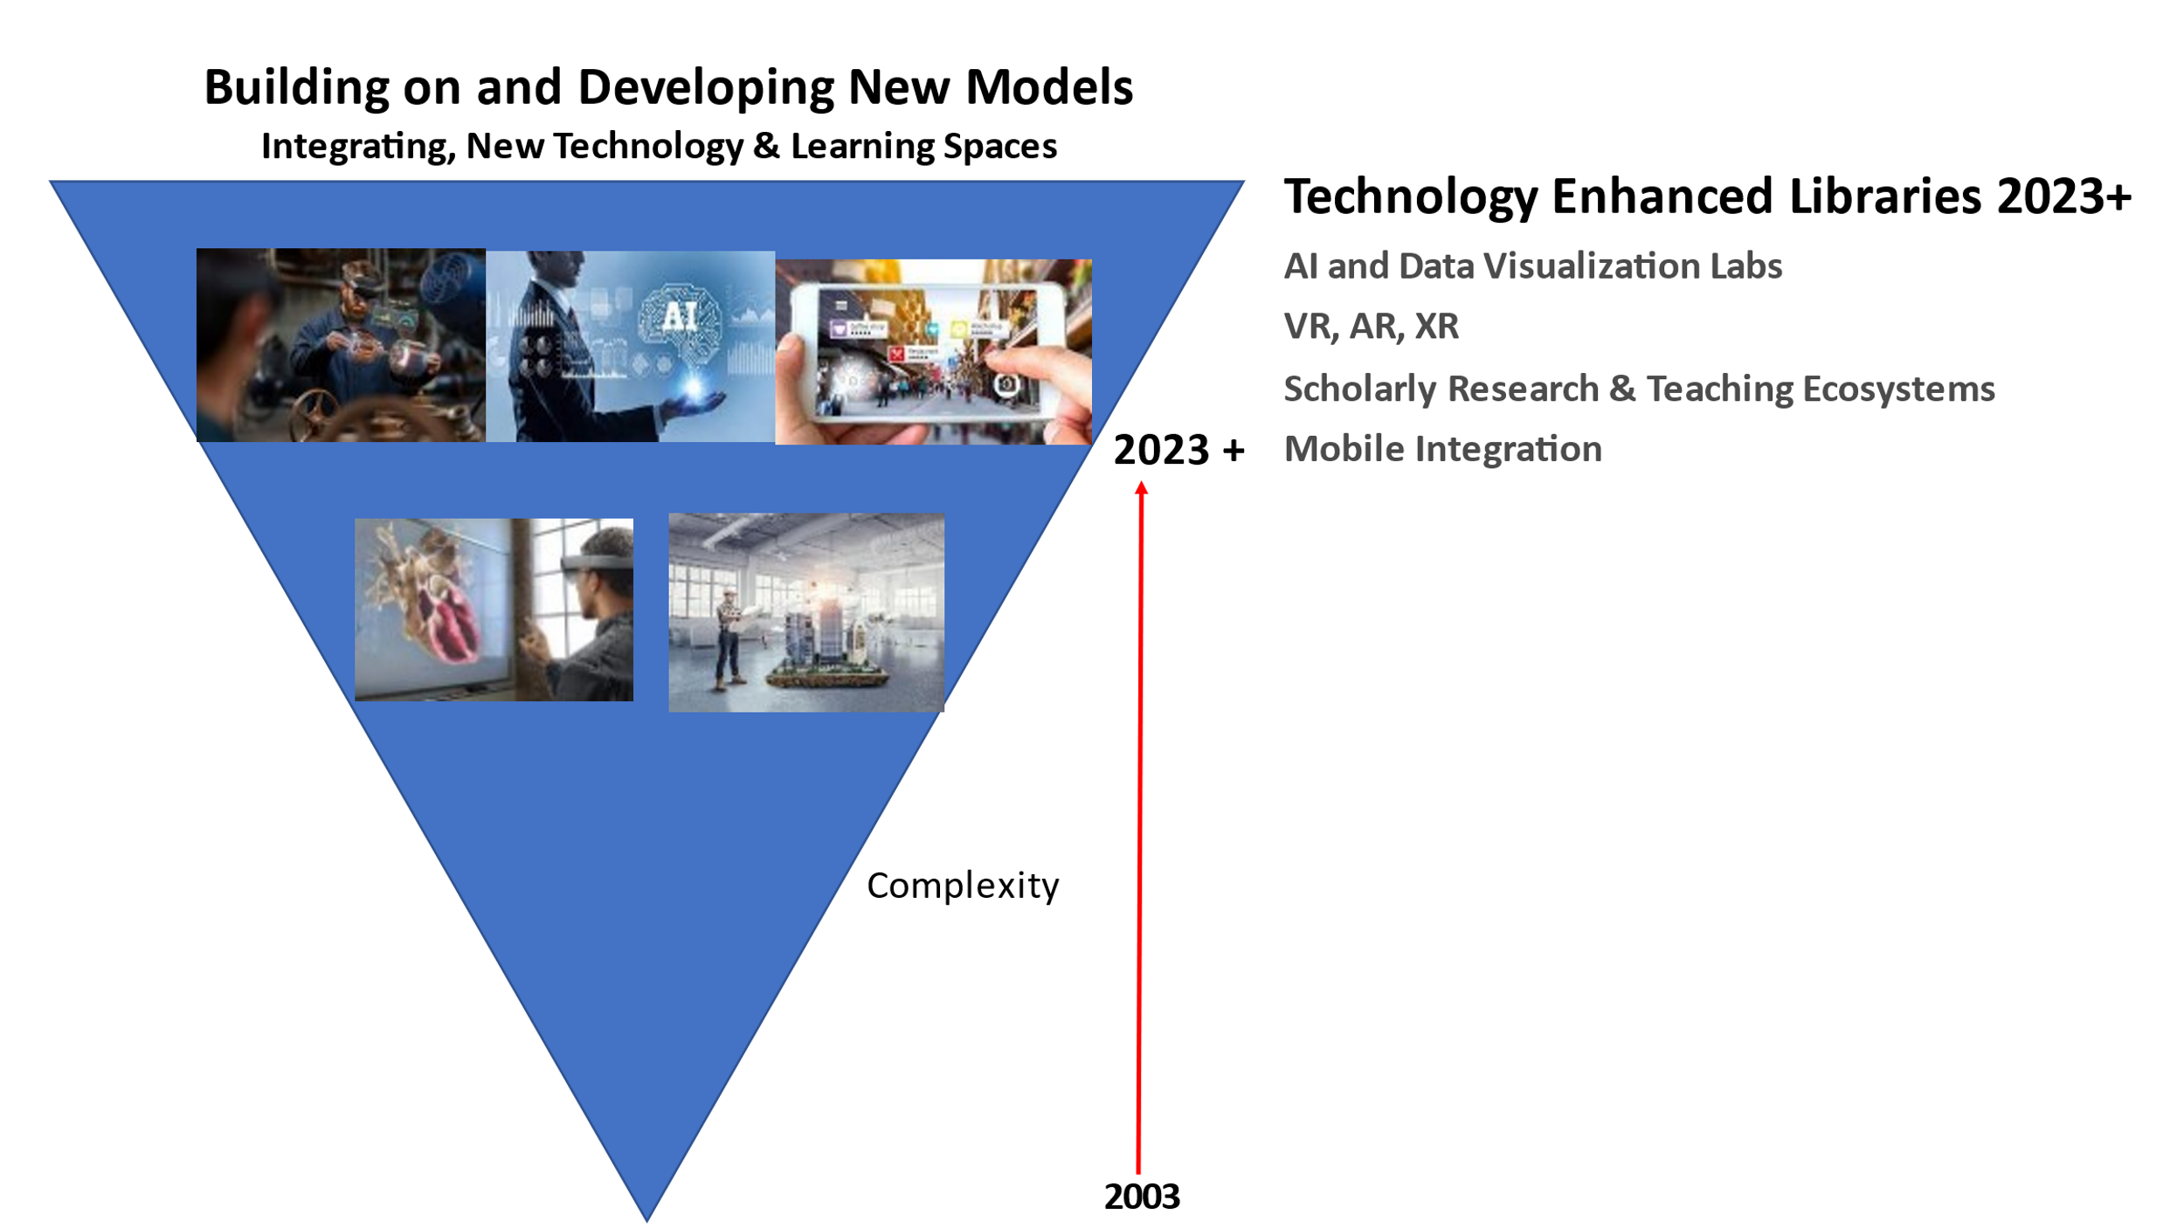
Acknowledgments
Developing these types of technology enhanced learning spaces is always a larger group effort, often occurring over many years. The author gratefully acknowledges the multitude of library, university staff, faculty architects, engineers, and university IT with whom he has worked with over the years on all these projects. This includes the various library faculties and professional staffs at University of Miami Libraries, Otto Richter Library, University of West Florida John C. Pace Library for the Skylab, Texas State University Libraries and Mississippi State University Libraries.

References
Articles, Book Chapters and Interviews

- Uzwyshyn, R (2019). “Choosing What Technology Goes into a Learning Commons (Interview). In Lynn D. Lampert and Colleen Meyers-Martin (Eds.). Creating a Learning Commons: A Practical Guide for Librarians (Ch. 6, pp. 75-90). London: Rowman and Littlefield, 2019.
- Uzwyshyn, (2018). Academic Libraries and Technology: An Environmental Scan Towards Future Possibility, Proofs. In J. G. Holbrook (Ed.), Academic and Digital Libraries: Emerging Directions and Trends (pp. 63-86). New York: Nova Publishers, 2018.
- Uzwyshyn, R (October 2016). Back to the Future: From Book Warehouse to Library Learning Commons. Informed Librarian, October 2016.
- Uzwyshyn, R. (2015). One Size May Not Fit All: Pragmatic Reflections on 3D Printers for Academic Learning Environments. Computers in Libraries. Special Issue on Innovation. 35:10, December 2015. pp. 4-8.
- Uzwyshyn, R (2003). "Teaching Vermeer in Miami: Interdisciplinarity, Visual Information and a Visual Thinking Strategies Institute" Books and Bytes: The University of Miami Libraries Journal. Volume 2, Issue 2, Winter, 2003.
- Uzwyshyn, R. (2016). How to Build a 3D Printing Center: Experts Share Their Advice for Setting up a Campus 3D Printing Lab. Weldon, D. Campus Technology Interview. October 27, 2016.
- Uzwyshyn, R (2010). "Envisioning the Skylab: The New University of West Florida Libraries 21st Century Learning Space"(Panel Presentation). For Academic Learning Spaces Conference: Invention, (Re)Invention and Innovation, June 7 & 8, 2010, Florida State University. (PDF), Books & Bytes Article.

Conference Presentations and Videos

- Texas State University Library (2020). New Albert Alkek Library Learning Commons Video Tour: Explore, Create Discover.
- Texas State University Library (2019) Technology Enhanced Library Spaces Video. Alkek One Student Success: Digital Literacy Coming Soon.
- Developing Technology Enhanced Learning Spaces for New Millennia Academic Libraries (Detailed, Brief Presentation). WLIC IFLA 2023. Rotterdam, Netherlands, 2023.
- Uzwyshyn, R (2017). S, M, XL: Libraries & Learning Commons. Campus Technology Annual Conference, Coffee Talk Conversations, Chicago, McCormick Convention Center, July 18, 2017.
- Uzwyshyn, R. (2016). From Zero to Hero: 3D Printer Infrastructures for College and University Campuses. Campus Technology Annual Conference, Boston, MA, August 1-4, 2016.
- Uzwyshyn, R. (2016) Transforming Your University or College Library: From Book Warehouse to Innovation-Centered Learning Commons. For Transformational Technology in Higher Education: Thriving as a Connected Campus. Quick v., 2016.
- Uzwyshyn, R (2016). New Directions in Student Learning Spaces. (Panel Presentation). Transformational Technology in Higher Education. Quick v., 2016.
- Uzwyshyn, R (2014). Makerspaces, Visualization Walls and Imagineering Design for Learning Commons (PPT), 2014.
- Uzwyshyn, R (2010). "Envisioning the Skylab: The New University of West Florida Libraries 21st Century Learning Space"(Panel Presentation). For Academic Learning Spaces Conference: Invention, (Re)Invention and Innovation, June 7 & 8, 2010, Florida State University. (PDF), Books & Bytes Article.

Internal Presentations, White Papers and Planning Documents
Keith, J., Pankl, L & Uzwyshyn, R. (2023). Mississippi State University Exploration, Research and Learning Environment Proposal: The ERLE. (PDF, PPT). 2023.
- Uzwyshyn, R (2023). Research Data Repository and AI Learning Center Proposal. 2023. Mississippi State University. 2023.
- Uzwyshyn, R. (2023) MSU Digitization Lab, Digital Media Center and AI/Data Center Donor Funding Proposal, 2023.
- Uzwyshyn, R (2014). Makerspaces, Visualization Walls and Imagineering Design for Learning Commons (PPT), 2014.
- Uzwyshyn, R (2010). Skylab Information Commons2010 (Award equipment/space, Skylab Manager).
- Uzwyshyn, R. (2010) UWF Libraries Digital Literacy Studio.
- Uzwyshyn, R (2008). UWF Libraries Learning Commons: White Paper; Library Digital Initiatives Program and Literacy Studio; IT Departmental Space, Human Resources Needs; University Libraries New Media Centre.
- Uzwyshyn, R (2006). Library Digital Literacy Studio/Laboratory Proposal (PDF).

New AI Applications for Library Architectural and Technology Visioning (2023)

- Open AI. Prompt Engineering. ChatGPT: AI Chatbot
- Adobe Inc. Firefly (Photoshop). Generative AI for Creators.
- Runway and Stability AI. Stable Diffusion: Text to Image AI Photorealistic Modelling Software
- Midjourney Inc. Midjourney: AI Images from Natural Language Processing

